CENWP-OD-B 16 July 2024

MEMORANDUM FOR THE RECORD

SUBJECT: 24BON030 MFR CI LPS Pond Pacific Lamprey Mortality

On the morning of 16 July, Project Biologists discovered one Pacific Lamprey mortality in the Cascades Island LPS pond (CI LPS Pond). The fish was scanned for PIT tags, measured, inspected, and returned to the river.

- Species – Pacific Lamprey (Entosphenus tridentatus)
- Origin – Unknown.
- Length – Approximately 37.1 cm.
- Marks and tags – None.
- Marks and Injuries found on carcass – None.
- Cause and Time of Death – Unknown.
- Future and Preventative Measures – None.

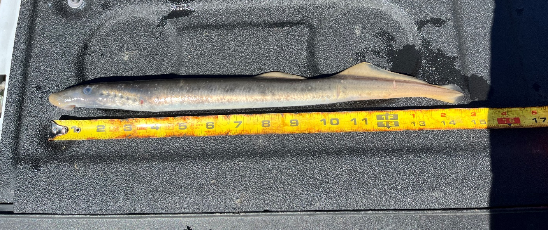

Sincerely,
Bonneville Project Fisheries

